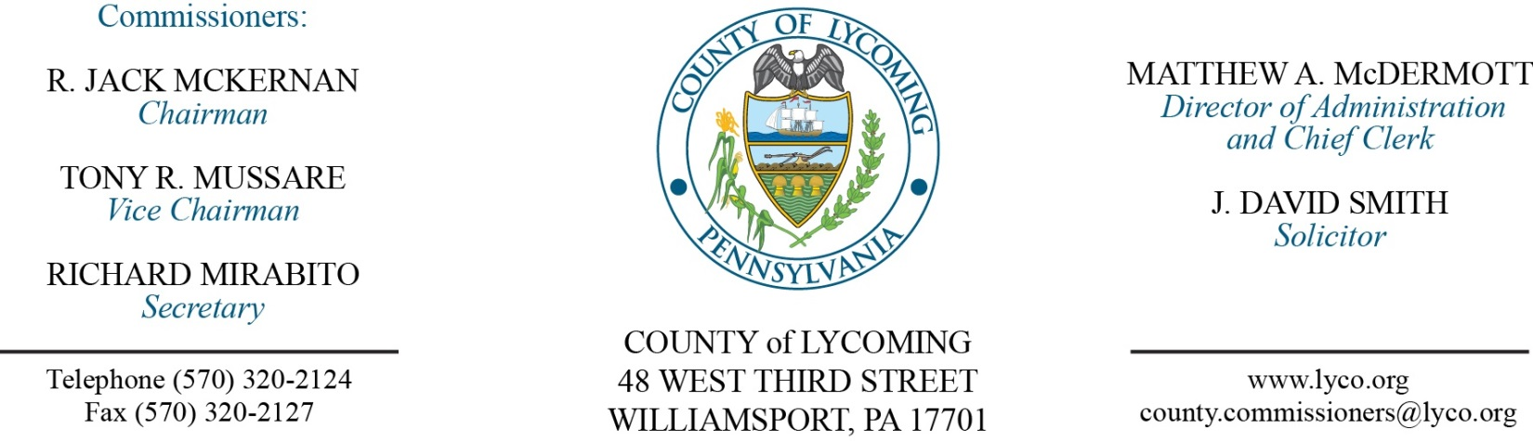
Commissioners’ Meeting Agenda
October 6, 2016

Opening Prayer

Pledge to the Flag

1.0 OPERATIONS

1.1 Convene Commissioners’ meeting.

1.2 Approve the minutes of the previous meetings.

1.3 Receive public comments (agenda items only).

2.0 ACTION ITEMS

2.1 Proclaim October 2-8, 2016 as 4-H week in Lycoming County. (Jeanette Blank)

2.2 Proclaim October 7, 2016 as Manufacturing Day in Lycoming County.

2.3 Adopt resolution 2016-21 for county bridge 106 agreement with Penn DoT. (Mark Murawski)

2.4 Approve subrecipient agreement with the City of Williamsport for WATS. (Mark Murawski)

2.5 Approve professional service agreement with Julian Allatt for conflicts attorney services not to exceed $35,000/annually. (Adrianne Stahl)

2.6 Approve professional service agreement with David Pelachick for Juvenile Probation Department. (Nancy Ackley)

2.7 Approve Emergency Management Performance Grant agreement with the Commonwealth of PA in the amount of $135,060. (Dan Dorman)

2.8 Approve TDA changes at RMS: Remove Training & Safety Manager grade 11; In support Services change shop Clerk III grade 4 to Operations & Support services Clerk grade 5; Ind. Maintenance Specialist grade 7/8 to Work Crew Foreman Grade 5/6; Business Office Clerk IV grade 5 t6o Administrative Specialist/Training Coordinator grade 6. (Roxanne Grieco)

2.9 Approve the following personnel actions:
RMS – reclassification of Charles H. Opp to full time Work Crew Foreman – Pay grade 8 - $21.589073/hour effective 10/9/16 (Change in title/jobcode, hold grade/rate for one year then move to grade 6 adjusted rate.).
RMS – reclassification of Bethany A. Stugart to full time Administrative Specialist/Training Coordinator – Pay grade 6 - $22.85/hour effective 10/9/16 (Change in title, grade, rate, job code.).
RMS – reclassification of Richard L. Shief to full time Operations & Support Services Clerk – Pay grade 7 - $22.030182/hour effective 10/9/16 (Change in title only, hold grade & hourly rate until 12/18/16 then change to grade 5 at adjusted rate.).

Recess Commissioners’ Meeting

3.0 SALARY BOARD

3.1 Convene Salary Board.

3.2 Approve update to salary schedule: Remove Training & Safety Manager grade 11; In support Services change shop Clerk III grade 4 to Operations & Support services Clerk grade 5; Ind. Maintenance Specialist grade 7/8 to Work Crew Foreman Grade 5/6; Business Office Clerk IV grade 5 t6o Administrative Specialist/Training Coordinator grade 6.

3.3 Adjourn Salary Board.

Reconvene Commissioners’ Meeting

5.0 REPORTS/INFORMATION ITEMS

5.1 Present 10 year service pin to Jill Schriner.

6.0 COMMISSIONER COMMENT:

7.0 PUBLIC COMMENT:

8.0 NEXT REGULARLY SCHEDULED MEETING: Planning Session on Tuesday, October 11, 2016.

9.0 ADJOURN COMMISSIONERS’ MEETING.

